PORTRAIT, HANDS and COLOR… oh my!

Name: ___________________________________ PER: ______________ DATE ________________________
2.0: Creating, Performing, and Participating in the Visual Arts

4.3: Formulate and support a position regarding the aesthetic value of a specific work of art and change or defend that position after considering the views of others

☐ STEP 1: CHOOSE someone you admire to draw and procure a photo of them.
NOTE: If you are drawing yourself, you will either need a mirror or a photo of
yourself)

☐ STEP 2: Create a SKETCH of your subject, complete with face and at least one
hand
NOTE: If a hand is covering part of the face, at least 50% of the face MUST be seen AND the entire head must be within the frame of the paper.
FOR HELP DRAWING HANDS OR PORTRAITS, REFER TO THE WEEBLY!

☐ STEP 3: TEST colors on your sketch. (YOU MAY USE OIL PASTELS)

☐ STEP 4: Ask a peer and MR. SOLIS to fill out the CRITIQUE SHEET based on your
sketch.

☐ STEP 5: ASK for a set of OIL PASTELS and a sheet of paper to complete the final
drawing and commence making your FINAL DRAWING.

☐ STEP 6: Answer the questions in the WRITTEN REFLECTION.

☐ STEP 7: Score yourself and submit the following to Mr. Solis!

- One sketch
- One Peer Review
- One Final Drawing
- One Reflection Sheet
- One Score Sheet

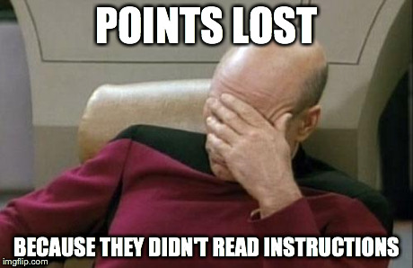

CRITIQUE SHEET

Peer Review #1

PEER’S NAME ________________________________ SIGNATURE ______________________________

- Describe (2) parts of the sketch that you really like.

- What’s one thing you would change about the sketch. Why?

Review #2

NAME __MR. SOLIS__________________________ SIGNATURE ______________________________

- Describe (2) parts of the sketch that you really like.

- What’s one thing you would change about the sketch. Why?

REFLECTIONS

Name ________________________ PER _____ DATE _____________________

- After your first peer review, did you change your sketch? Why or why not?

- After Mr. Solis’ suggestions, did you change your sketch? Why or why not?

3. Explain why you the subject of your drawing is admirable?

4. MAKE SURE YOUR FIRST NAME, LAST NAME, AND PERIOD ARE ON THE
BACK in the bottom right hand corner!!

SCORE SHEET

Name ________________________ PER _____ DATE _____________________

Category | Your score | Mr. Solis’  score
FINAL DRAWING – NEATNESS AND COMPLETENESS
See rubric below

FINAL DRAWING – FACE
See rubric below

FINAL DRAWING – HANDS
See rubric below

TOTAL (For St. 2.0)
Take average of the three scores
CRITIQUE SHEET w/ two responses (+4)
CRITIQUE SHEET w/ one response (+2)

REFLECTION
See rubric below

TOTAL (For St. 4.3)
Take average of the three scores

RUBRIC
 | 4 | 3 | 2 | 1
FINAL DRAWING – NEATNESS AND COMPLETENESS | Artwork is complete and has no ‘stray marks’ | Artwork is complete w/ some ‘stray marks’ | Artwork is complete, but very messy | Artwork is incomplete
FINAL DRAWING – FACE | All of the proportions are accurate | Most of the proportions are accurate | Most of the proportions are inaccurate | No proportions
FINAL DRAWING – HANDS | All of the proportions are accurate | Most of the proportions are accurate | Most of the proportions are inaccurate | No proportions
REFLECTION | Students answers the questions in complete sentences without errors. | Student answers the question with meaningful responses, but errors in grammar exist. | Student’s answers are in incomplete sentences. | Student does not turn in reflection

