Tajima HS Solis AP CALC BC

LT 1.1B – Estimating Limits RETEACH

Name ____________________________________________ PER __________ DATE___________________________
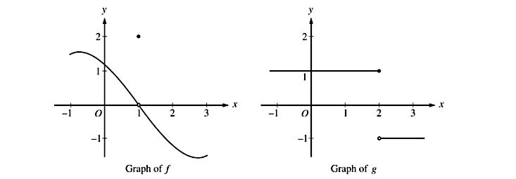

1. Consider the functions above. What transformation is applied to f to create f(x+1)? Similarly, what transformation is applied to f to create f(x+1)?

2. Draw the transformed functions of f(x+1) and g(x+1) below.
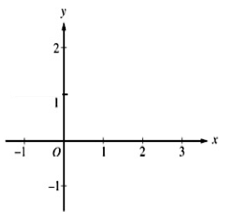

Graph of f(x+1) Graph of g(x+1)

3. Using your new graphs, answer the questions below.

