Prehistoric Art

AFRICA
“COLD “
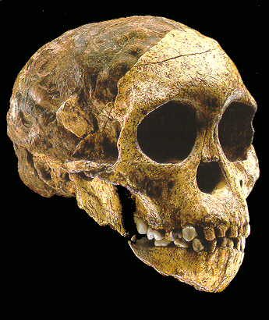
Homo erectus
850,000 BC

Culture Prehistoric The original humans
before recorded history.
Origin North Africa) Humans first originated in
Northeast Africa
Location North Africa → All the world
Prehistoric people spread
all over the world.
Dates 850,000 BC = 1st humans → 7,000 BC = 1st writing
and the end of prehistoric era.

“GRAPES”

Government Tribes with Chiefs as leaders
Religions (2) Ancestor Worship = the belief that dead people become gods..
Polytheism = the belief in many gods.

Art Architecture Post & Lintel Temples like Stonehenge & Chatal Huyuk.
Sculpture Formalistic & Realistic Venus & Woman of Brassempouy
Painting Caves = mostly animals, probably soul paintings to capture
the spirit of animals before the hunt.
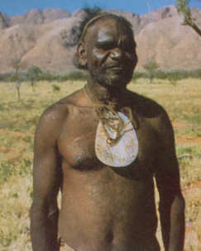
Philosophy Fear & Awe = nature & the spirits are to be feared & awed.
Economy Trade & Barter = before money people exchanged goods.
Science Agriculture, Ceramics, Wheel, Fire making, Weapons

Government

Tribes Groups of people united together for protection, companionship, and help.
Chiefs The leader of a tribe. Chiefs were usually the strongest or smartest. →

Religion

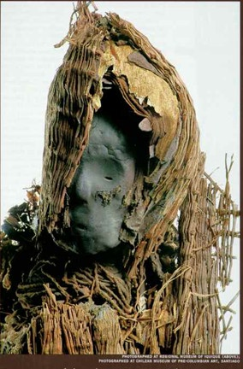
Ancestor Worship The belief that dead
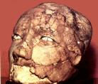
people become gods..

Polytheism The belief in many gods.

Gods There may have been gods for
most “aspects” or parts of life:
sun, death, floods, war, etc.

Depiction It’s uncertain how they
thought their gods looked.
No depictions of a god have
been identified yet.

Philosophy


Fear & Awe
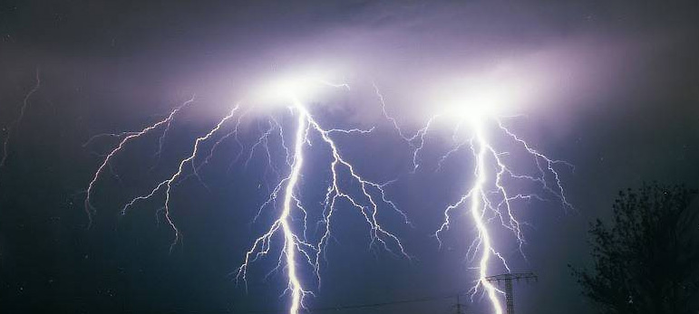
Life was full of fear and awe of
nature. Lightning and thunder
meant the god’s were angry.

Architecture
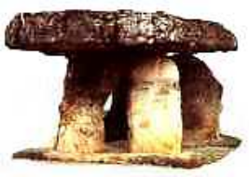 Dolmen
Post and Lintel

Building method Post and lintel, (vertical columns and
a cross beam on top). Made out
of stone as shown here. A dolmen
is a post and lintel structure as shown.

Temples & buildings

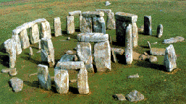
Title Stonehenge
Artist unknown
Media stone
Date 2,000 BC
Location England
Use Astrological calendar (a way to
tell the longest & shortest
days by the sun’s position)

Title: Chatal Huyuk
Artist: Unknown
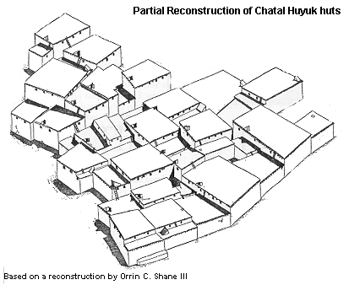
Media: stone, mud, wood, straw
Ethnicity: In what is now Turkey
Date: 7,000 BC
Use: city

Uniqueness The houses touch each other without
streets. This may have been for
protection. There are no windows or
doors. Entrance to each house is
from holes in the roof.

Sculpture
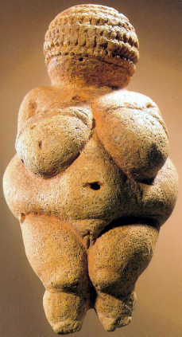
Sculptures Often quite small. Use is unknown,but by
studying modern prehistoric people we can guess.

Title Venus of Willendorf
Artist unknown
Media stone
Date 25,000 BC
Use fertility amulet; ( a good luck charm for pregnant women)
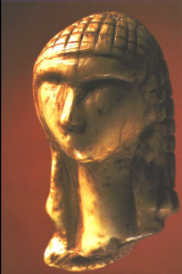

Title: Woman of Brassempouy
Artist: Unknown
Media: Stone
Ethnicity: Brassempouy, France
Date: 23,000 BC
Use: Unknown use.

Painting

Title Caves at Lascaux
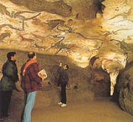
Artist unknown
Media chalk & minerals
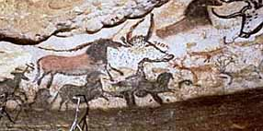
Date 12,000 BC
Location Lascaux, France

Use Probably a

Soul Painting to

capture the soul

of the animal you

are about to hunt.

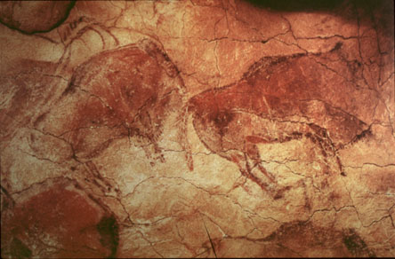

Title Caves at Alta Mira
Artist unknown
Media chalk & minerals
Date 12,000 BC
Location Alta Mira, Spain

Use See Above

