Using the SMPs to Analyze Student Work

Objective: Students will be able to identify the standards of mathematical practice in student work on various types of mathematical problems and justify their reasoning.

Agenda:

- Have students complete a Do Now where they create a 5-word sentence for a selection of SMPs starting with – “I can…”
- Share student work, display “Student Friendly” SMP posters and debrief.
- Identify the 6 Gallery Walk posters around the room, each with a problem and a student’s work. Explain to students that their objective is to travel to each poster and leave a card describing which practice is illustrated. Before they write their SMP, they should read what other groups have left on the problem. Only catch – once 3 groups have used a standard on a poster, your group must use a different standard!
- Once groups have circulated, share each problem on the board and choose one/two groups for each problem and ask them to explain why they chose the SMP they did.
- Students complete the debrief activity independently.

Assessment: Collect the Debrief Questions.

HW: None

Materials: -6 Gallery Walk Posters
-6 SMP Cards for each group in the class
-Tape, Thumb Tacs, etc. to hang student responses on the wall.
-Debrief Questions

STATION A

The Set-Up: A student who just learned about exponents is asked to solve the following problem.

The Problem: A bank account starts with $3 in it and is doubling every day. Write an equation to show how much money is in the account after t days.

The Work:

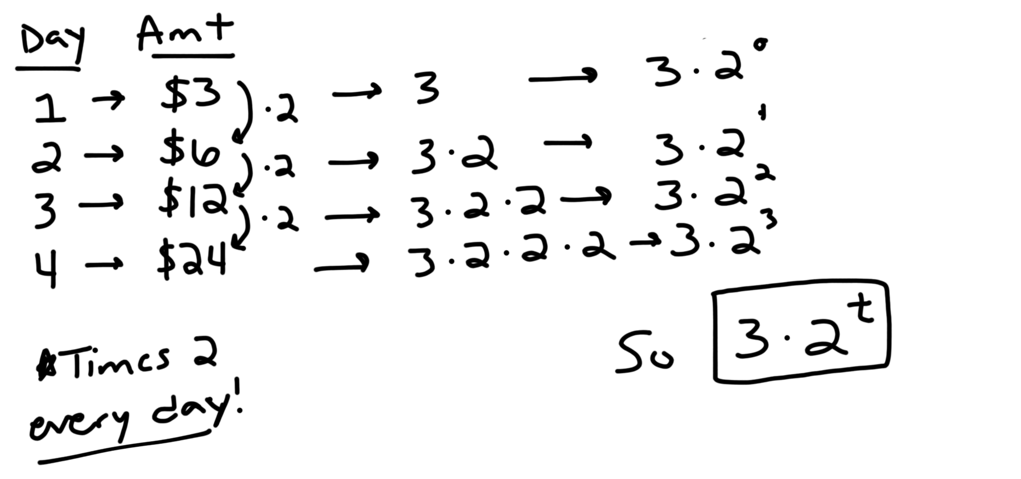

Which mathematical practice(s) does this student show? Explain why!

Place your group’s card below…

STATION B

The Set-Up: Two students are asked to solve the same equation.

The Problem: Solve:

The Work:

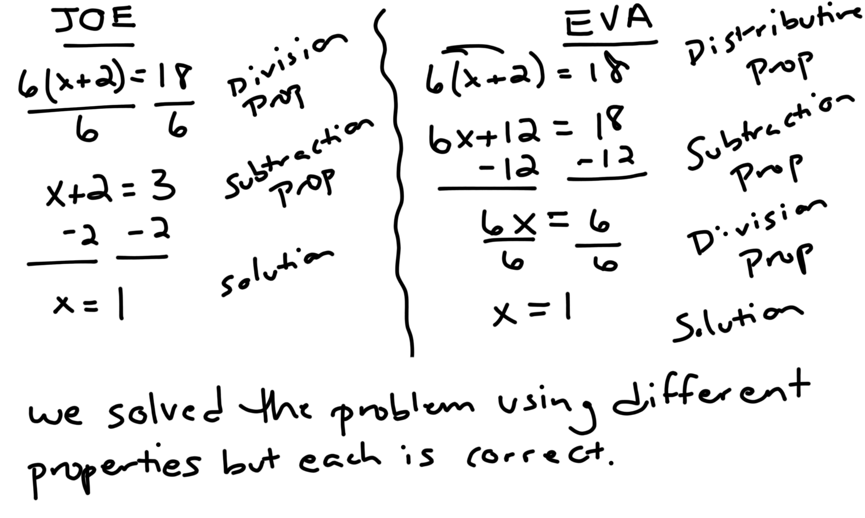

Which mathematical practice(s) does this student show? Explain why!

Place your group’s card below…

STATION C

The Set-Up: A student is given a diagram on paper and asked the following question.

The Problem: Classify the shape:

The Work: 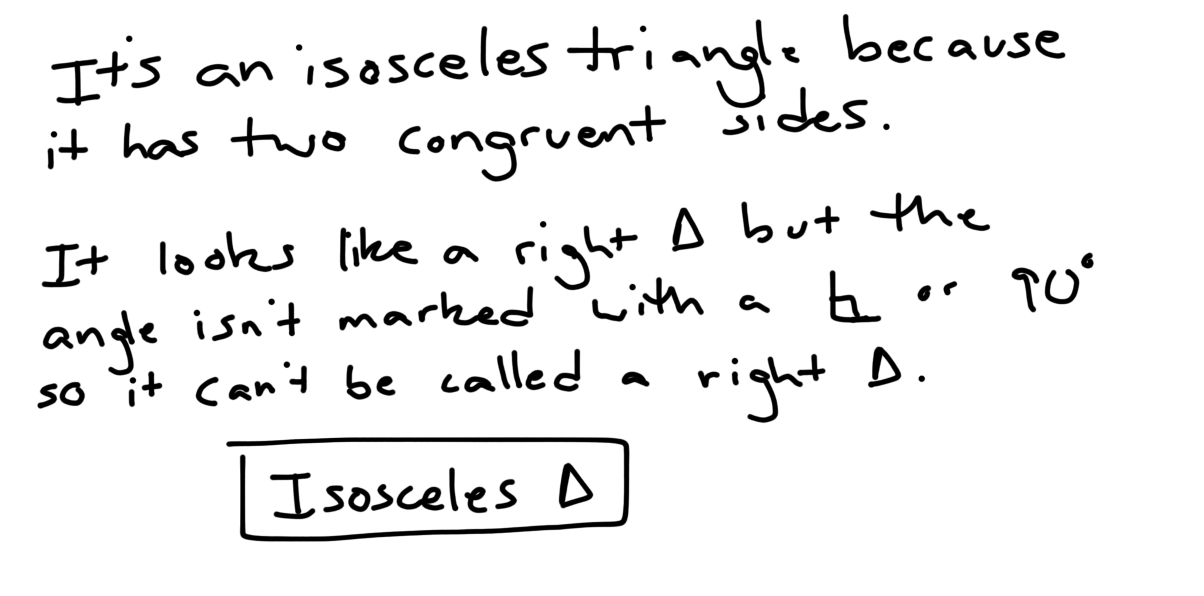

Which mathematical practice(s) does this student show? Explain why!

Place your group’s card below…

STATION D

The Set-Up: A student is asked to solve the following problem using any approach he/she wants.

The Problem: Your friend goes on a hike from your campsite, walking 3 miles north and 5 miles east. How far from the campsite is he?

The Work:

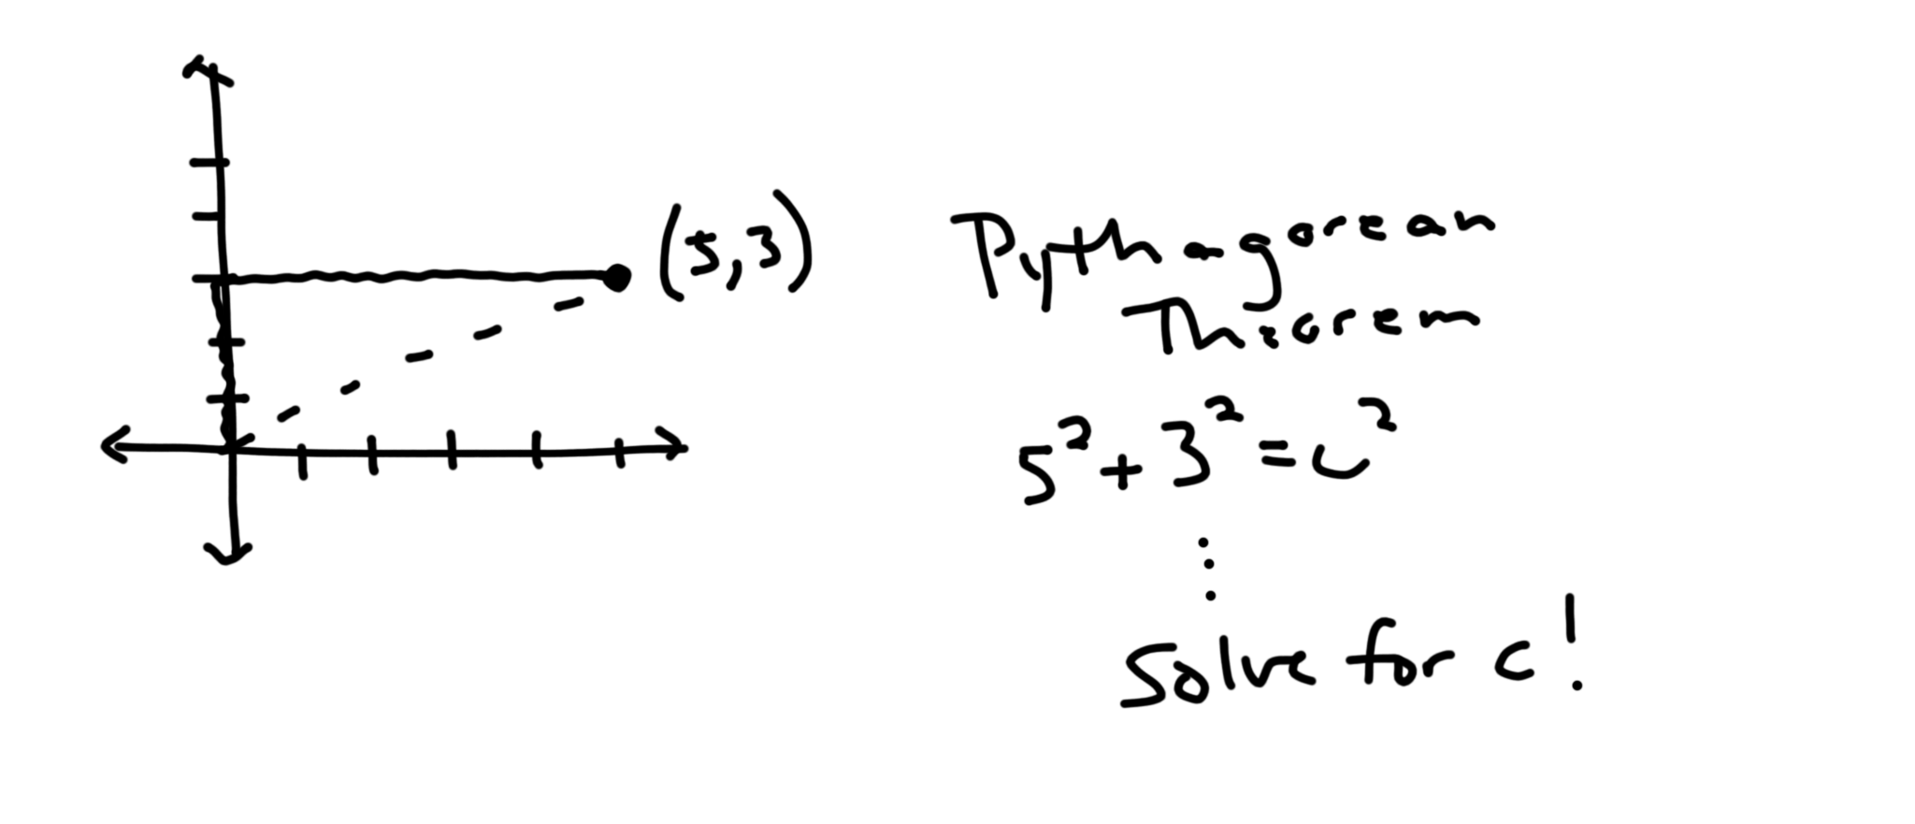

Which mathematical practice(s) does this student show? Explain why!

Place your group’s card below…

STATION E

The Set-Up: A student is asked to complete error analysis on a partner’s work to the problem below. Their work and the student’s comments are shown below.

The Problem: The test scores on a recent assessment are shown in the table below. Describe how the class did on the test. How do you know?

Stdt | A | B | C | D | E | F | G | H | I | J | K
Score | 87 | 75 | 22 | 90 | 68 | 72 | 81 | 91 | 77 | 80 | 86

The Work:

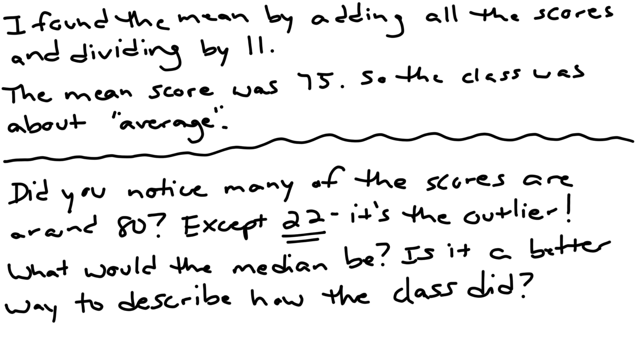

Which mathematical practice(s) does this student show? Explain why!

Place your group’s card below…

STATION F

The Set-Up: A student was given information about t-shirts being sold at the local mall and was asked the question that follows.

The Problem: A t-shirt shop tracked their business over the course of a week and wanted to tell when their business was strongest. Help them determine which day they should hire another employee due to the high number of customers.

The Work:

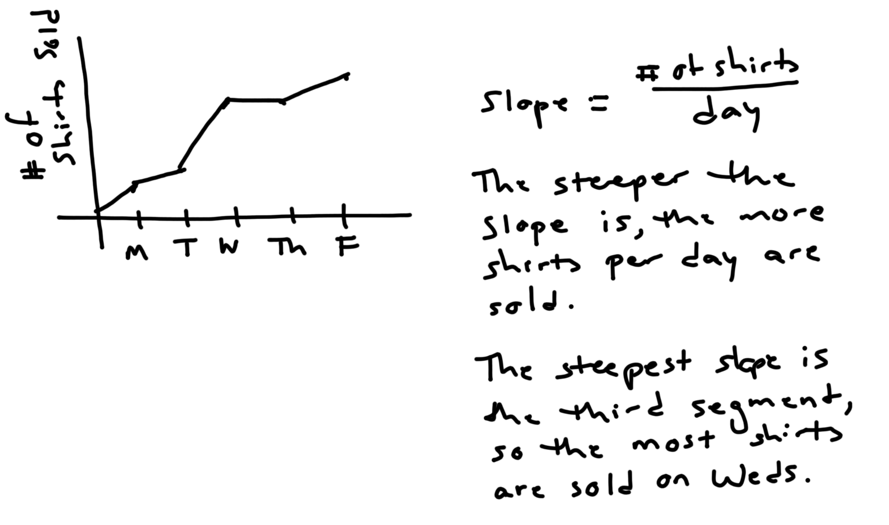

Which mathematical practice(s) does this student show? Explain why!

Place your group’s card below…

This demonstrates SMP _________, which is:  BECAUSE:  Group Members: | This demonstrates SMP _________, which is:  BECAUSE:  Group Members:
This demonstrates SMP _________, which is:  BECAUSE:  Group Members: | This demonstrates SMP _________, which is:  BECAUSE:  Group Members:

Name: ________________________________________________________________________ Date:______________________ Per: ________

SMP Gallery Walk Debrief Questions

1. What SMP do you think will apply to the greatest number of problems we will solve in this class? Why?

2. Describe SMP 2 (Reason abstractly and quantitatively) in your own words. Why is this SMP important?

3. What SMP do you understand best? Explain specific ways that you have used this practice in math classes in the past.

4. What is an appropriate way to show SMP 3 (Construct viable arguments and critique the reasoning of others)? What is an inappropriate way to demonstrate this standard?

5. Which SMP is the most confusing to you? What part of it is most difficult for you to understand?

